T z
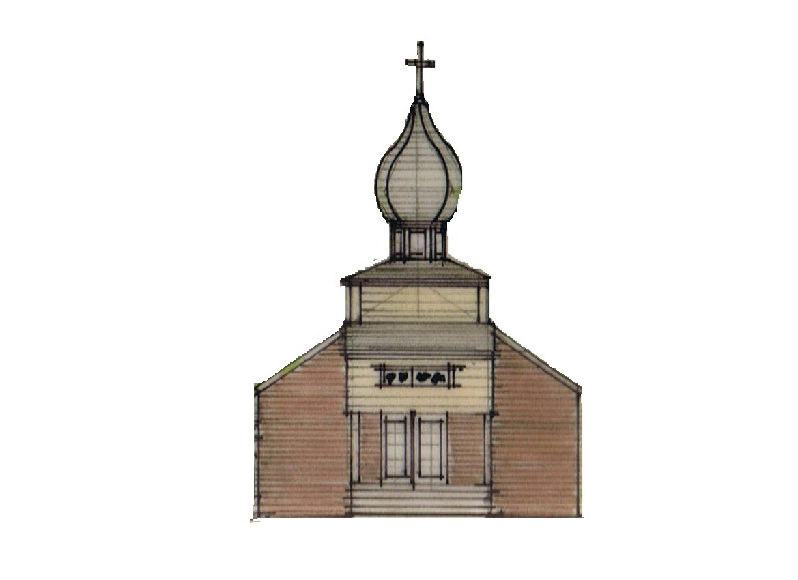
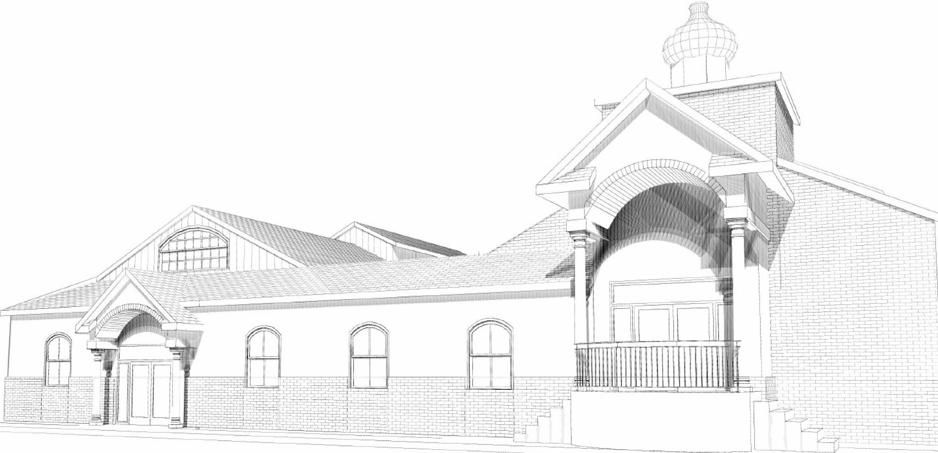

St. Michael the Archangel Orthodox Church

2300 W. Huntington Drive, Kirkwood Hwy, Wilmington, Delaware 19808

Rev. James Weremedic, Rector • (302) 995-6775 • Cell (570) 764-4323

Email: frjamesw@hotmail.com • Web: www.stmichael-delaware-oca.org

Vespers & Confessions: Saturday, 4:00 pm

Hours, Divine Liturgy & Fellowship: Sunday, 8:40 am

Sunday, January 5, 2014

28th SUNDAY AFTER PENTECOST. Tone 3. EVE OF THEOPHANY. Sunday before Theophany. Hieromartyr Theopemptus, Bishop of Nicomedia, and Martyr Theonas. Ven. Syncletica of Alexandria. Prophet Micah. Virgin Apollinaria of Egypt. Ven. Phosterius the Hermit. Ven. Menas of Sinai. Ven. Gregory of Crete. Ven. Romanos, Martyr.
Reader’s Schedule

DATE 3RD HOUR 6TH HOUR EPISTLE
Jan-5 WEREMEDIC, L SOUDER, C PECK
Jan-12 WEREMEDIC, J WEREMEDIC, L. CAREY
Jan-19 RILEY, J RILEY, A PECK

Date | Fellowship  Coffee Hour | Service  Duty | Church Cleaners | Library
5-Jan | Souder/Riley | Elia/Morjana | Manna/Mihret | Gundersen
12-Jan | Hojnicki/Flynn/Roberts | Riley/Baldytchev | Finck | Nichols
19-Jan | Kraiter/Cretu | Sulpizi/Finck | Whalen | Farrell

Services for the Feast of Holy Theophany:
- Compline & Matins for Holy Theophany on Sunday, January 5th at 5:00 p.m.
- Divine Liturgy on Monday, January 6th at 9:00 a.m., with the Blessing of Holy Water, afterwards. Bring your own bottles for refill, please!
 What is Family Promise?

Family Promise is a network of churches and synagogues that host homeless families for a week at a time. Four or five homeless families – parents and children – come to live in our church 3 to 4 times a year.

How does this work? Our classrooms become bedrooms with inflatable mattresses, bedding, and care packages. Volunteer van drivers bring the program’s current families from the Family Promise Center to our church every evening of the host week. A network of organized volunteers then fill in roles in the church building each night of the host week to collectively cook dinner for the families plus volunteers (about 20 people) and remain in the church with our guests as hosts to offer comfort and companionship during their stay. Two volunteers spend the night in the building (sleeping is encouraged!) in a private room and set out breakfast supplies for the families before they are driven back to the center again where they shower, the kids catch the school bus, and the parents work with the Family Promise staff on finding jobs or housing.
Does this sound like homeless ministry as you know it? Our job is hospitality, conversation, prayer, and welcome.

What can you do to help?
St. Philip’s Lutheran Church has been hosting for about 3 years. We are blessed with ample room to host our guests but we are always in need of caring volunteers who are able to help us host the families. We don’t fix their problems; we just provide a safe, comfortable, and friendly place. We’re looking for St. Michael’s help to cover each of our volunteer roles! Individuals, small groups, and families with kids are encouraged. Roles are organized in such a way that any one volunteer can volunteer for just one short session or for multiple sessions throughout the host week.
If you can cook a meal, spend a night, drive a van, or just come and be friendly, we could use your help!
Keep an eye open for upcoming volunteer trainings and sign-up! If you are interested in learning more about Family Promise, please contact Brandon and Karen Zinnato at novemberbasket@yahoo.com or (302) 229-6032.
St. Philip’s next Host Week is February 9th – February 16th!!!

2 Timothy 4:5-8 (Epistle, Sunday Before)
But you be watchful in all things, endure afflictions, do the work of an evangelist, fulfill your ministry. For I am already being poured out as a drink offering, and the time of my departure is at hand. I have fought the good fight, I have finished the race, I have kept the faith. Finally, there is laid up for me the crown of righteousness, which the Lord, the righteous Judge, will give to me on that Day, and not to me only but also to all who have loved His appearing.

Mark 1:1-8 (Gospel, Sunday Before)
The beginning of the gospel of Jesus Christ, the Son of God.
As it is written in the Prophets: “Behold, I send My messenger before Your face, Who will prepare Your way before You.” The voice of one crying in the wilderness: ‘Prepare the way of the LORD; Make His paths straight.’ “ John came baptizing in the wilderness and preaching a baptism of repentance for the remission of sins. Then all the land of Judea, and those from Jerusalem, went out to him and were all baptized by him in the Jordan River, confessing their sins. Now John was clothed with camel’s hair and with a leather belt around his waist, and he ate locusts and wild honey. And he preached, saying, “There comes One after me who is mightier than I, whose sandal strap I am not worthy to stoop down and loose. I indeed baptized you with water, but He will baptize you with the Holy Spirit.

Our Bible Study Group continues to meet on the 1st and 3rd Thursday of each month from 10:00 am - 12:00 noon. We continue to use Barbara Pappas's book First and Second Corinthians for direction.

Prayers for the Departed: Sorin, Noria Morjana, Dorothy Jones.

Prayers for the Sick and Needy: Mat. Lisa Weremedic, Alice Dryden, William Dryden, Agnes Timchak, Wendy Boyer, Olga Riley, Anna Hotrovich, Mary Guretsky, Marie Holowatch, Joseph Wojciechowski, Keith Eldridge.

Prayers for Celebration: Marie Holowatch celebrating her 91st birthday today. Mary Guretsky celebrating her 92nd birthday on Jan. 9th.

A Good Samaritan collection will be taken Today and the first Sunday of each month. Please be generous with your offering.

We welcome our visitors and guests and invite you to join us for coffee hour in the church hall following the Liturgy.

Our Joint 2014 Winter Wilmington Parish Gathering of parishioners from Ss. Peter and Paul and St. Michael will be on Friday, February 28. A new team, 87’ers, a development team for the 76’ers are playing in the Bob Carpenter Center in Newark, DE against the Sioux Falls Skyforce (Heat). Tickets are $15 per person. If anyone is interested, please sign-up on the form in the Vestibule. If we have at least 15 people going, our ‘Fan Experience’ at the game will be a “Chalk Talk” with the 87ers coaching staff about their plans for the game, in a meeting held in the locker rooms during the first minutes of warm-ups.

The sign-up sheet for House Blessings is in the narthex. Please indicate your preference for morning, afternoon or evening appointment. In addition, please indicate the days you will not be available. Father will schedule based on the information provided and will confirm a date/time with you. In addition, please provide a phone number to confirm appointments.

