T z
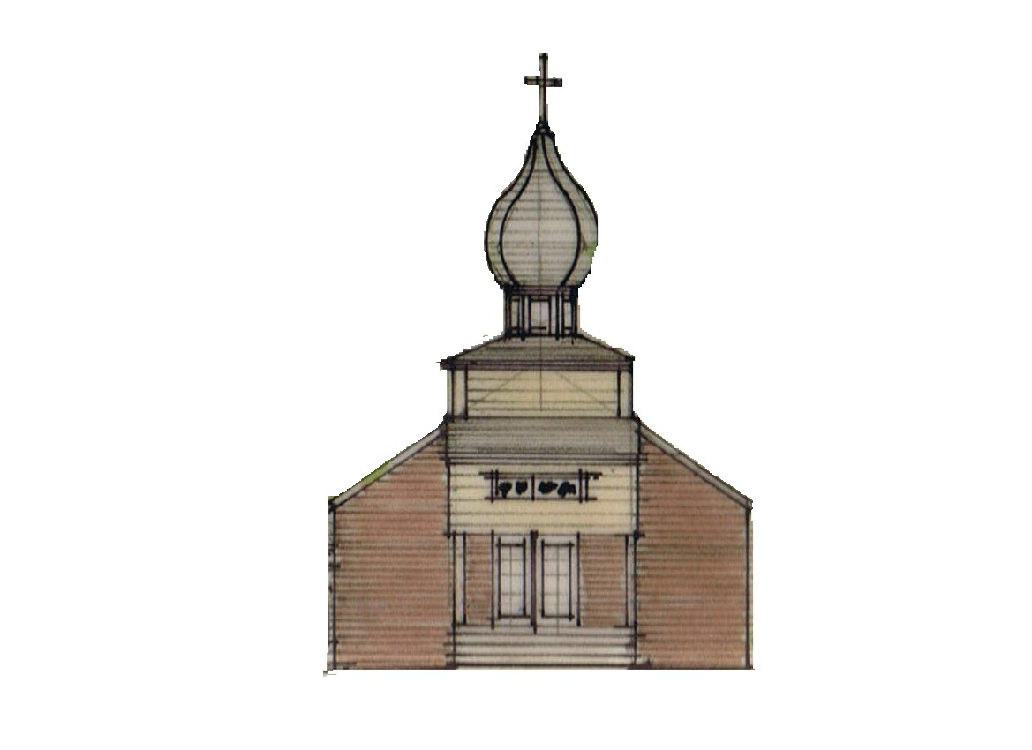


St. Michael the Archangel Orthodox Church

2300 W. Huntington Drive, Kirkwood Hwy, Wilmington, Delaware 19808

Rev. James Weremedic, Rector • (302) 995-6775 • Cell (570) 764-4323

Email: frjamesw@hotmail.com • Web: www.stmichael-delaware-oca.org

Vespers & Confessions: Saturday, 6:00 pm

Hours, Divine Liturgy & Fellowship: Sunday, 8:40 am

Sunday, August 24, 2014
11th SUNDAY AFTER PENTECOST. Tone 2. Hieromartyr Eutychius, disciple of St. John the Theologian. Translation of the Relics of St. Peter, Metropolitan of Moscow and All Russia. Ven. Arsenius, Abbot of Komel. Martyr Tation of Claudiopolis (305). Virgin Martyr Cyra of Persia. St. George Limniotes the Confessor of Mt. Olympus. St. Kozma of Berat, Evangelizer of Southern Albania. Repose of New Hieromartyr Cosmas of Aetolia, Equal-to-the-Apostles.
df
Reader’s Schedule

DATE 3RD HOUR 6TH HOUR EPISTLE
Aug 24 S. BUNITSKY K. BUNITSKY PECK
Aug 31 J. RILEY A. RILEY J.RILEY
Sep 7 SOUDER K. BUNITSKY J. WEREMEDIC

Date | Fellowship Hour | Service Duty | Church Cleaners | Library
24-Aug | Bacuta | Souder, Poletaev | Riley | Gregors
31-Aug | Elia, Gunderson,  Farrell | Bunitsky, Kendall | Carey, Bunitsky | Dozier
7-Sep | Souder, Riley | Elia, Morjana | Manna, Mihret | Gundersen

Immediately following the Divine Liturgy will be an 11-year Panikhida for Edward Michael Hojnicki offered by his family.

1 Corinthians 9:2-12 (Epistle)
If I am not an apostle to others, yet doubtless I am to you. For you are the seal of my apostleship in the Lord.
My defense to those who examine me is this: Do we have no right to eat and drink? Do we have no right to take along a believing wife, as do also the other apostles, the brothers of the Lord, and Cephas? Or is it only Barnabas and I who have no right to refrain from working? Who ever goes to war at his own expense? Who plants a vineyard and does not eat of its fruit? Or who tends a flock and does not drink of the milk of the flock? Do I say these things as a mere man? Or does not the law say the same also?
For it is written in the law of Moses, “You shall not muzzle an ox while it treads out the grain.” Is it oxen God is concerned about? Or does He say it altogether for our sakes? For our sakes, no doubt, this is written, that he who plows should plow in hope, and he who threshes in hope should be partaker of his hope. If we have sown spiritual things for you, is it a great thing if we reap your material things? If others are partakers of this right over you, are we not even more?
Nevertheless we have not used this right, but endure all things lest we hinder the gospel of Christ.

Matthew 18:23-35 (Gospel)
Therefore the kingdom of heaven is like a certain king who wanted to settle accounts with his servants. And when he had begun to settle accounts, one was brought to him who owed him ten thousand talents. But as he was not able to pay, his master commanded that he be sold, with his wife and children and all that he had, and that payment be made.
The servant therefore fell down before him, saying, ‘Master, have patience with me, and I will pay you all.’ Then the master of that servant was moved with compassion, released him, and forgave him the debt. But that servant went out and found one of his fellow servants who owed him a hundred denarii; and he laid hands on him and took him by the throat, saying, ‘Pay me what you owe!’
So his fellow servant fell down at his feet and begged him, saying, ‘Have patience with me, and I will pay you all.’ And he would not, but went and threw him into prison till he should pay the debt. So when his fellow servants saw what had been done, they were very grieved, and came and told their master all that had been done. Then his master, after he had called him, said to him, ‘You wicked servant! I forgave you all that debt because you begged me. ’Should you not also have had compassion on your fellow servant, just as I had pity on you?’ And his master was angry, and delivered him to the torturers until he should pay all that was due to him.
So My heavenly Father also will do to you if each of you, from his heart, does not forgive his brother his trespasses.

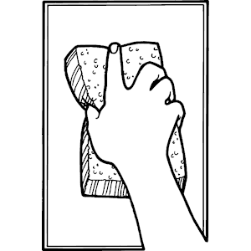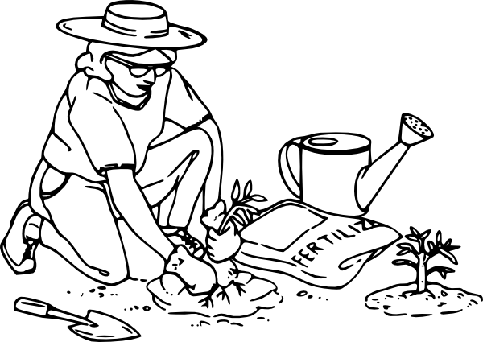

We’re Having A Cleaning Day!

On Saturday, September 13th, Saint Michael’s will have an inside/outside cleaning day. Please set aside some time to come out and help keep our church looking beautiful. A sign-up list will be placed in the vestibule so you know what needs to be done – and so you can volunteer to do it!

Donuts and coffee will be provided for our busy workers in the morning, and pizza and sodas in the afternoon.

Prayers for the Departed: Fr Sergius Willis, Mat. Vera Yuschak, Kamil Nassif, Edward Michael Hojnicki.

Prayers for the Sick and Needy:
Fr. John Bohush, Mat. Lisa, Mat. Mary Lynn Henry, Rdr. James Weremedic, Lidia Tokar, Lily Nassif, William Dryden, Agnes Timchak, Olga Riley, Anna Hotrovich, Mary Guretsky, Marie Holowatch, Marie Karawulan, Joseph Wojciechowski, Barbara Hicks, John and Olga Bilas.

On Saturday, August 30th and Sunday August 31st, Saint Michael’s parish will be hosting the Reverend, Bishop MARK. After Divine Liturgy, Bishop MARK will celebrate a Molieben Service in preparation for our 2014 – 2015 Church School Year. During this service the teachers and children will be asked to gather as a group in the center of the church to receive the Archbishop’s blessing for a fruitful year. To best prepare for this parish family event everyone, especially teachers, parents and students, is encouraged to attend Vespers and receive Confession on Saturday August 30th. I am hopeful that everyone in the Parish will welcome this opportunity to participate in these Services, teaching our children the importance of Parish life through our example. – Love in Christ, Tom Sulpizi

Nativity of our Most-Holy Lady Theotokos and Ever-Virgin Mary.

Sunday, Sept. 7: Vespers with Litya at 7:00 pm.
Monday, Sept. 8: Divine Liturgy 7:00 am.

Year to date, July 2014 Financials
Income from operations |  | $ 98,026.11
expenses for operations |  | $(105,151.20)
year to date income/(loss) - July |  | $ (7,125.09)

Announcing the 2014 Orthodox Institute, “Theosis: Your Life with God” which will offer courses on the topic of “Theosis.” These courses will serve as a spiritual retreat for those who attend and will educate them on this life-giving theology. The dates of the event are October 30-November 2, 2014, and the venue is The Antiochian Village, near Pittsburgh.

